Quiz_Lecture17

Name：刘承奇 Student ID：2018533249

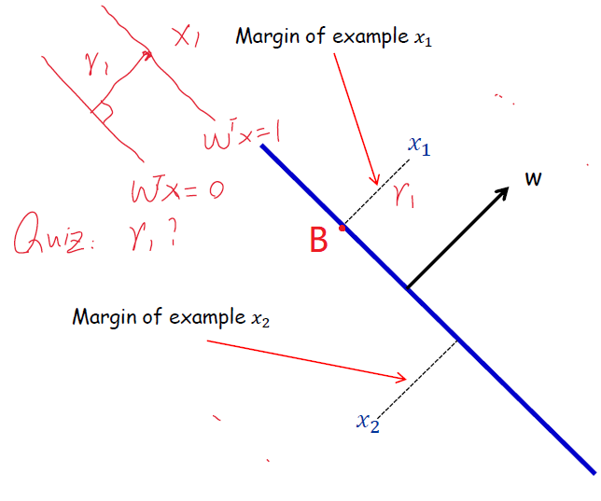

First, derive the formula :

Suppose the foot point is point B. Assume that  is above the hyperplane.  is the unit vector orthogonal to the hyperplane. So,  is the expression of B. Because B is on the hyperplane ,



But  can be under the hyperplane and  should always be positive, so . Because , we can express in this way: .

So, .